Default Settings - Algorithm:

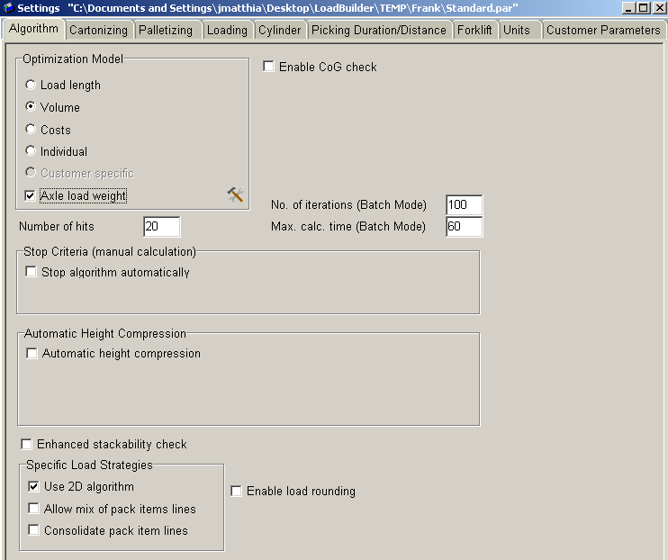

Controls which algorithm we use and how it is executed.

Relevant Fields:
Optimization Model:
Load Length: Used to optimize the length of the trailer when planning
Volume: Used to maximum volume
Costs: Not Used
Individual: Each pallet is evaluated individually
Axle Load Weight: Adhere to axle load weights set in Loading Unit database.

Enable CoG Check: If enabled allows a user to specify a range for the center of gravity based on percentage of length, width, and height.

Number of hits: Maximum number of valid results to be considered

No. of iterations (Batch Mode): The number of iterations to run through to find a valid solution. Increasing this number will yield a better result but will cost more time.

Max. calc. time (Batch Mode): The maximum time that each calculation will take. Increasing this will allow the number of iterations limit to be hit, yield better results, but cost more time.

Stop Criteria (manual calculation): Enabling this allows a user to specify a number of iterations to use when running a re-plan manually.

Automatic Height Compression: This is not used, as there is a hard coded rule that enforces it behind the scenes. Enabling it can cause unexpected and unwanted results.

Enhanced Stackability Check: Enforce stackability matrix at a item level while loading. This includes evaluating each item in a pallet.

